

HIRDLS
High Resolution Dynamics Limb Sounder
Earth Observing System (EOS)
Ice Water Content (IWC) Document
April 2013

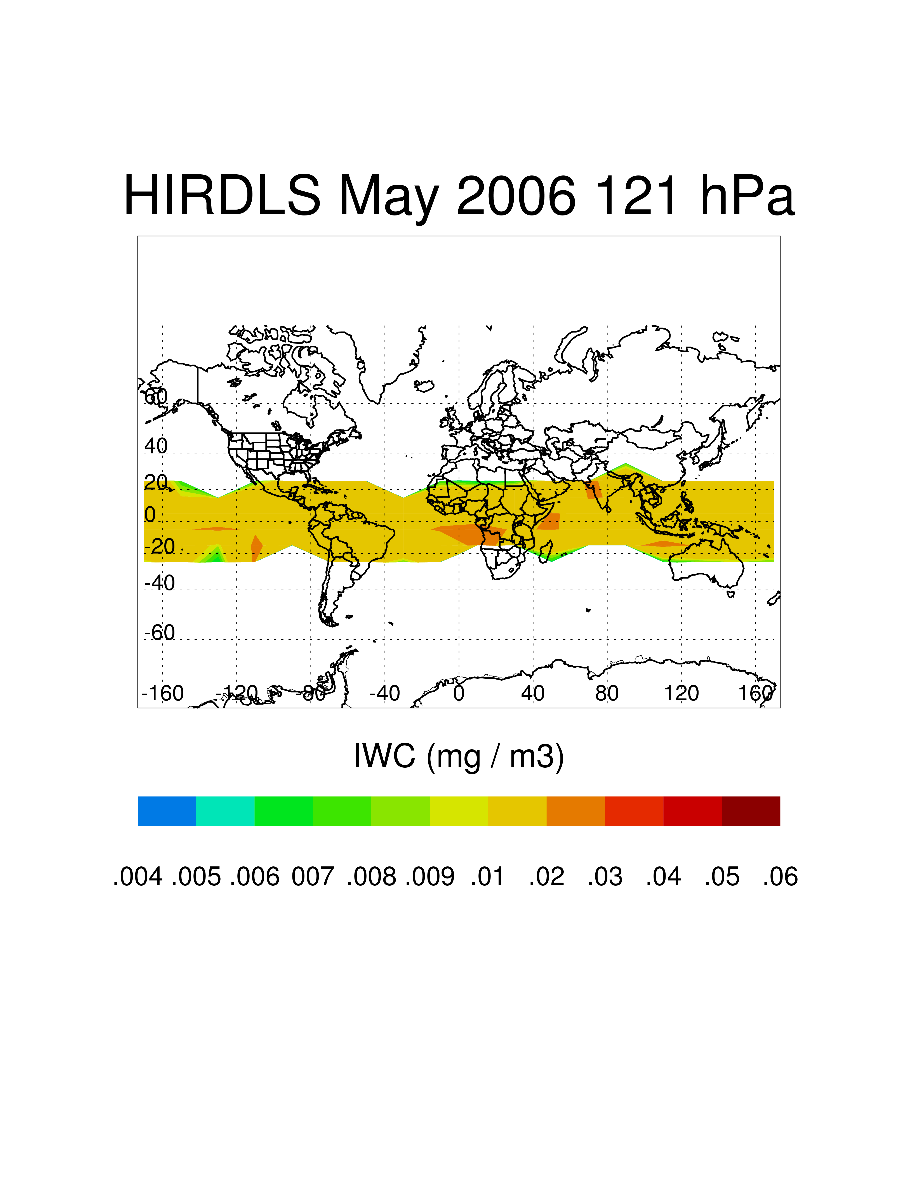
HIRDLS V7 IWC at 121 hPa in May 2006.
(See Figure 2, page 4 of document)

University of Colorado National Center for Atmospheric Research
Center for Limb Atmospheric Sounding Atmospheric Chemistry Division
Boulder, Colorado, USA Boulder, Colorado, USA
Ice Water Content

Data: Ice Water Content
Data Field Name: IWC
Useful Range: 215-82 hPa
Screening Criteria: Use the HIRDLS IWC data field in a qualitative manner
in the tropics
Vertical Resolution: 1 km (HIRDLS)
Units: g/m³
Contact: Steven Massie and Jonathan H. Jiang
Email: massie@ucar.edu, Jonathan.H.Jiang@jpl.nasa.gov

The HIRDLS and MLS experiments observe cirrus in the upper troposphere using measurements from infrared and microwave wavelengths, and therefore, the two experiments are sensitive to different cirrus radii ranges. HIRDLS is especially sensitive to subvisual cirrus, while the MLS experiment is sensitive to larger ice particles. The Ice Water Content joint product uses the version 3.3 MLS IWC data and IWC data derived from HIRDLS 12 micron extinctions which are transformed to IWC values by way of the transformation discussed below.

There is one data file containing monthly averaged IWC for months between February 2005 and December 2007 in a 20 ° longitude by 10° latitude grid. The pressure levels of the data are from 215 hPa to 82 hPa, with 6 pressure levels for the MLS data and 11 pressure levels for the HIRDLS experiment. The tropics are the geographical region of interest.

The primary benefit of the data fields is that they provide monthly fields of large and small cirrus particles which specify the relative geospatial distributions of these two particle types in the tropics.

The HIRDLS V7 extinction (Gille et al. 2011, Massie et al. 2007) is transformed into IWC by the technique discussed in Massie et al. (2002). In-situ size distributions are used in Mie calculations to calculate the extinction and volume density (μm³/cm³) values for an ensemble of in-situ size distributions from various field programs. The volume density is then related to the extinction by a linear least squares fit of the log of the extinction to log of the volume density. IWC (g/m³) follows by multiplication by the ice mass density of 0.97 gm/cm³, a good approximation for small cirrus particles. The equivalent H₂O (in ppmv) of the cirrus follows from dividing the volume density by the in-situ total gas number density and multiplying by the ice density of 0.97 gm/cm³.

The single data file contains HIRDLS IWC (g/m³), Volume Density (μm³/cm³), H₂O Equivalent (ppmv), Cloud Top Pressure (hPa), cloud frequency of occurrence (Frequency Clouds, percent), and MLS IWC (g/m³), as described below.

The MLS IWC data used in the averaging is based upon those produced by the MLS Science Team and discussed in Wu and Jiang (2004), Wu et al. (2008) and Livesey et al. (2011). Jonathan Jiang applied the screening procedures discussed in Section 3.14 of Livesey et al. (2011) using the ‘3σ’ screening method. The ranges of IWC that were averaged in the monthly MLS IWC data follows the Valid IWC values for each pressure levels as per the Table 3.14.1 recommendations.

Probability distribution functions of the HIRDLS and MLS IWC data at 121 hPa are presented in Figure 1. The averages use data for 2005 – 2007 and all available months. For convenience, the IWC values are expressed in mg/m³ units. Each experiment senses a different and limited range of IWC. The blank region near ~ 0.1 mg/m³ is due to radiative transfer considerations of each instrument (i.e. the specific ranges of optical depth which are sensed). Actual IWC PDF values of atmospheric cirrus are non-zero for all of the IWC range in the figure and the actual IWC PDF is a continuous curve.

Figures 2-4 display geographical distributions, for May 2006 at 121 hPa, of HIRDLS and MLS IWC, and display HIRDLS cirrus volume density and equivalent H₂O for illustrative purposes. The subvisual cirrus observed by HIRDLS is ubiquitous in the tropics, while the larger cirrus observed by MLS is more localized to regions where deep convection is prevalent.

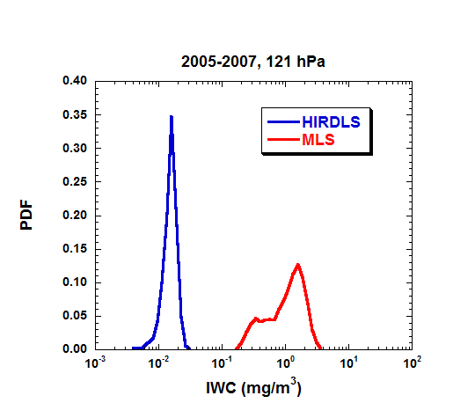

Figure 1. Probability distribution functions of HIRDLS and MLS IWC at 121 hPa.

Figure 2. HIRDLS IWC at 121 hPa in May 2006. The subvisual cirrus is ubiquitous throughout the tropics.

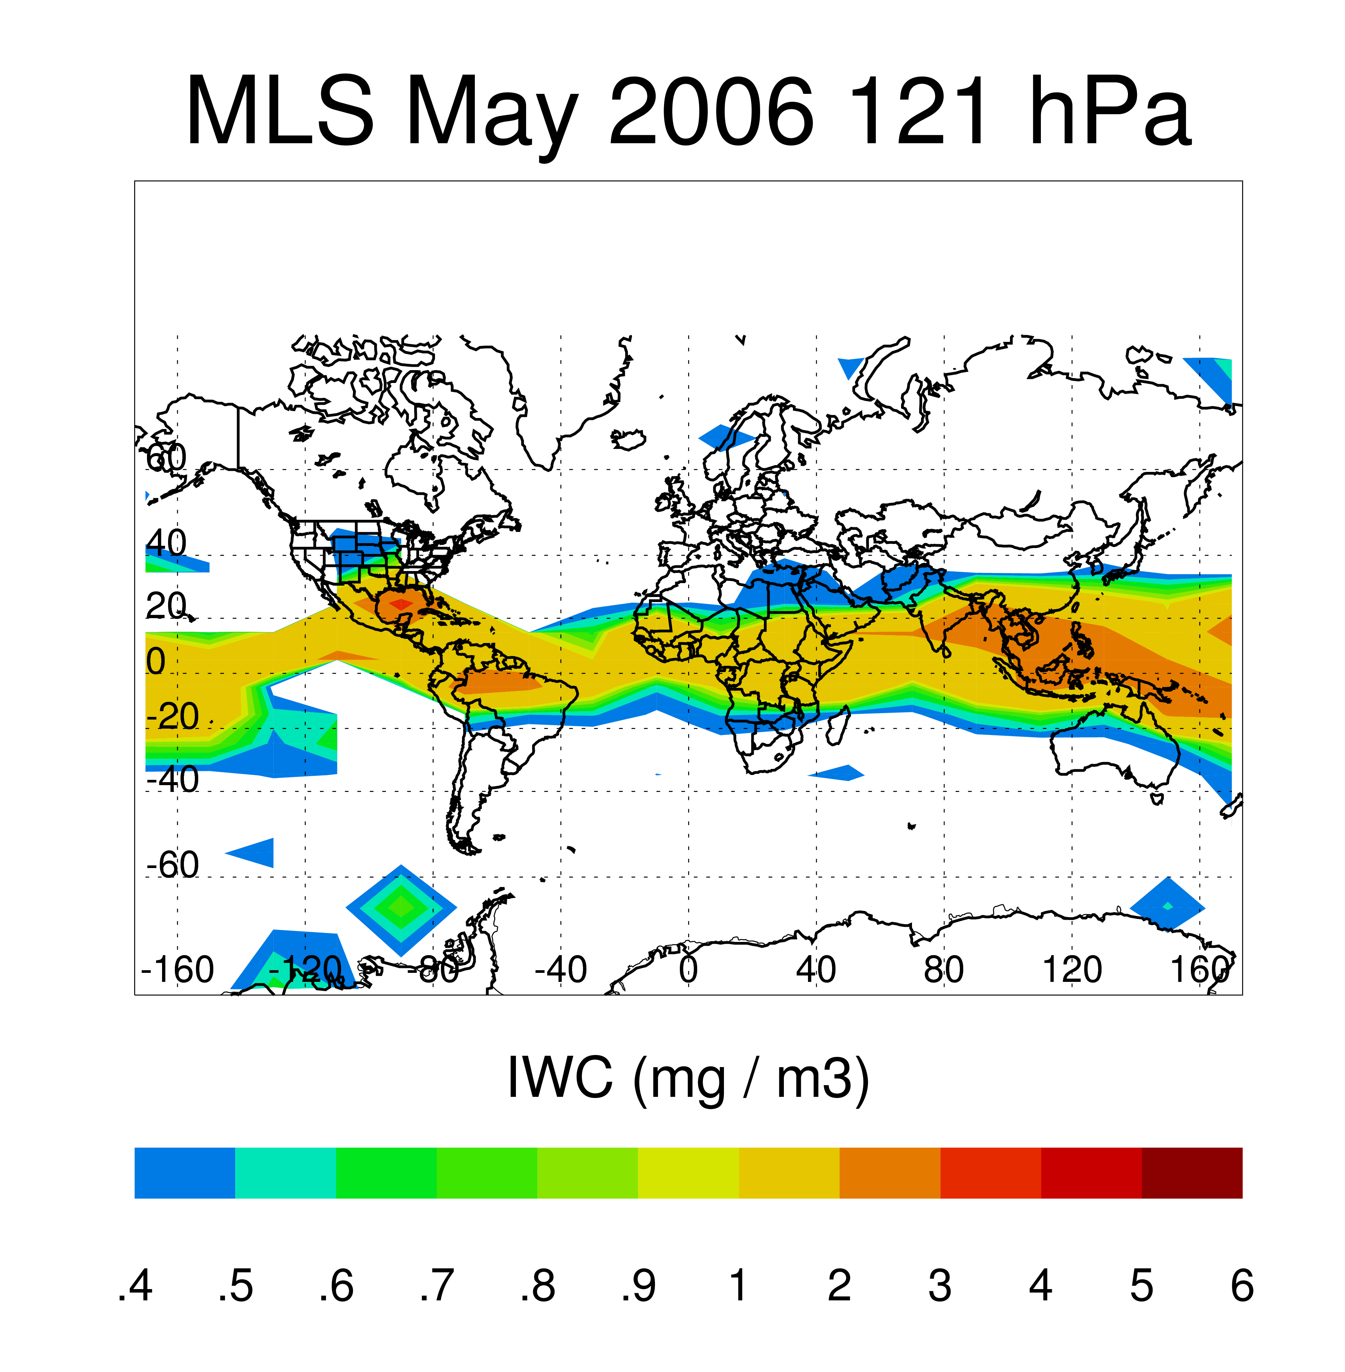
Figure 3. MLS IWC in May 2006 at 121 hPa. The IWC values observed by MLS are concentrated over Indonesia, where deep convection is localized.

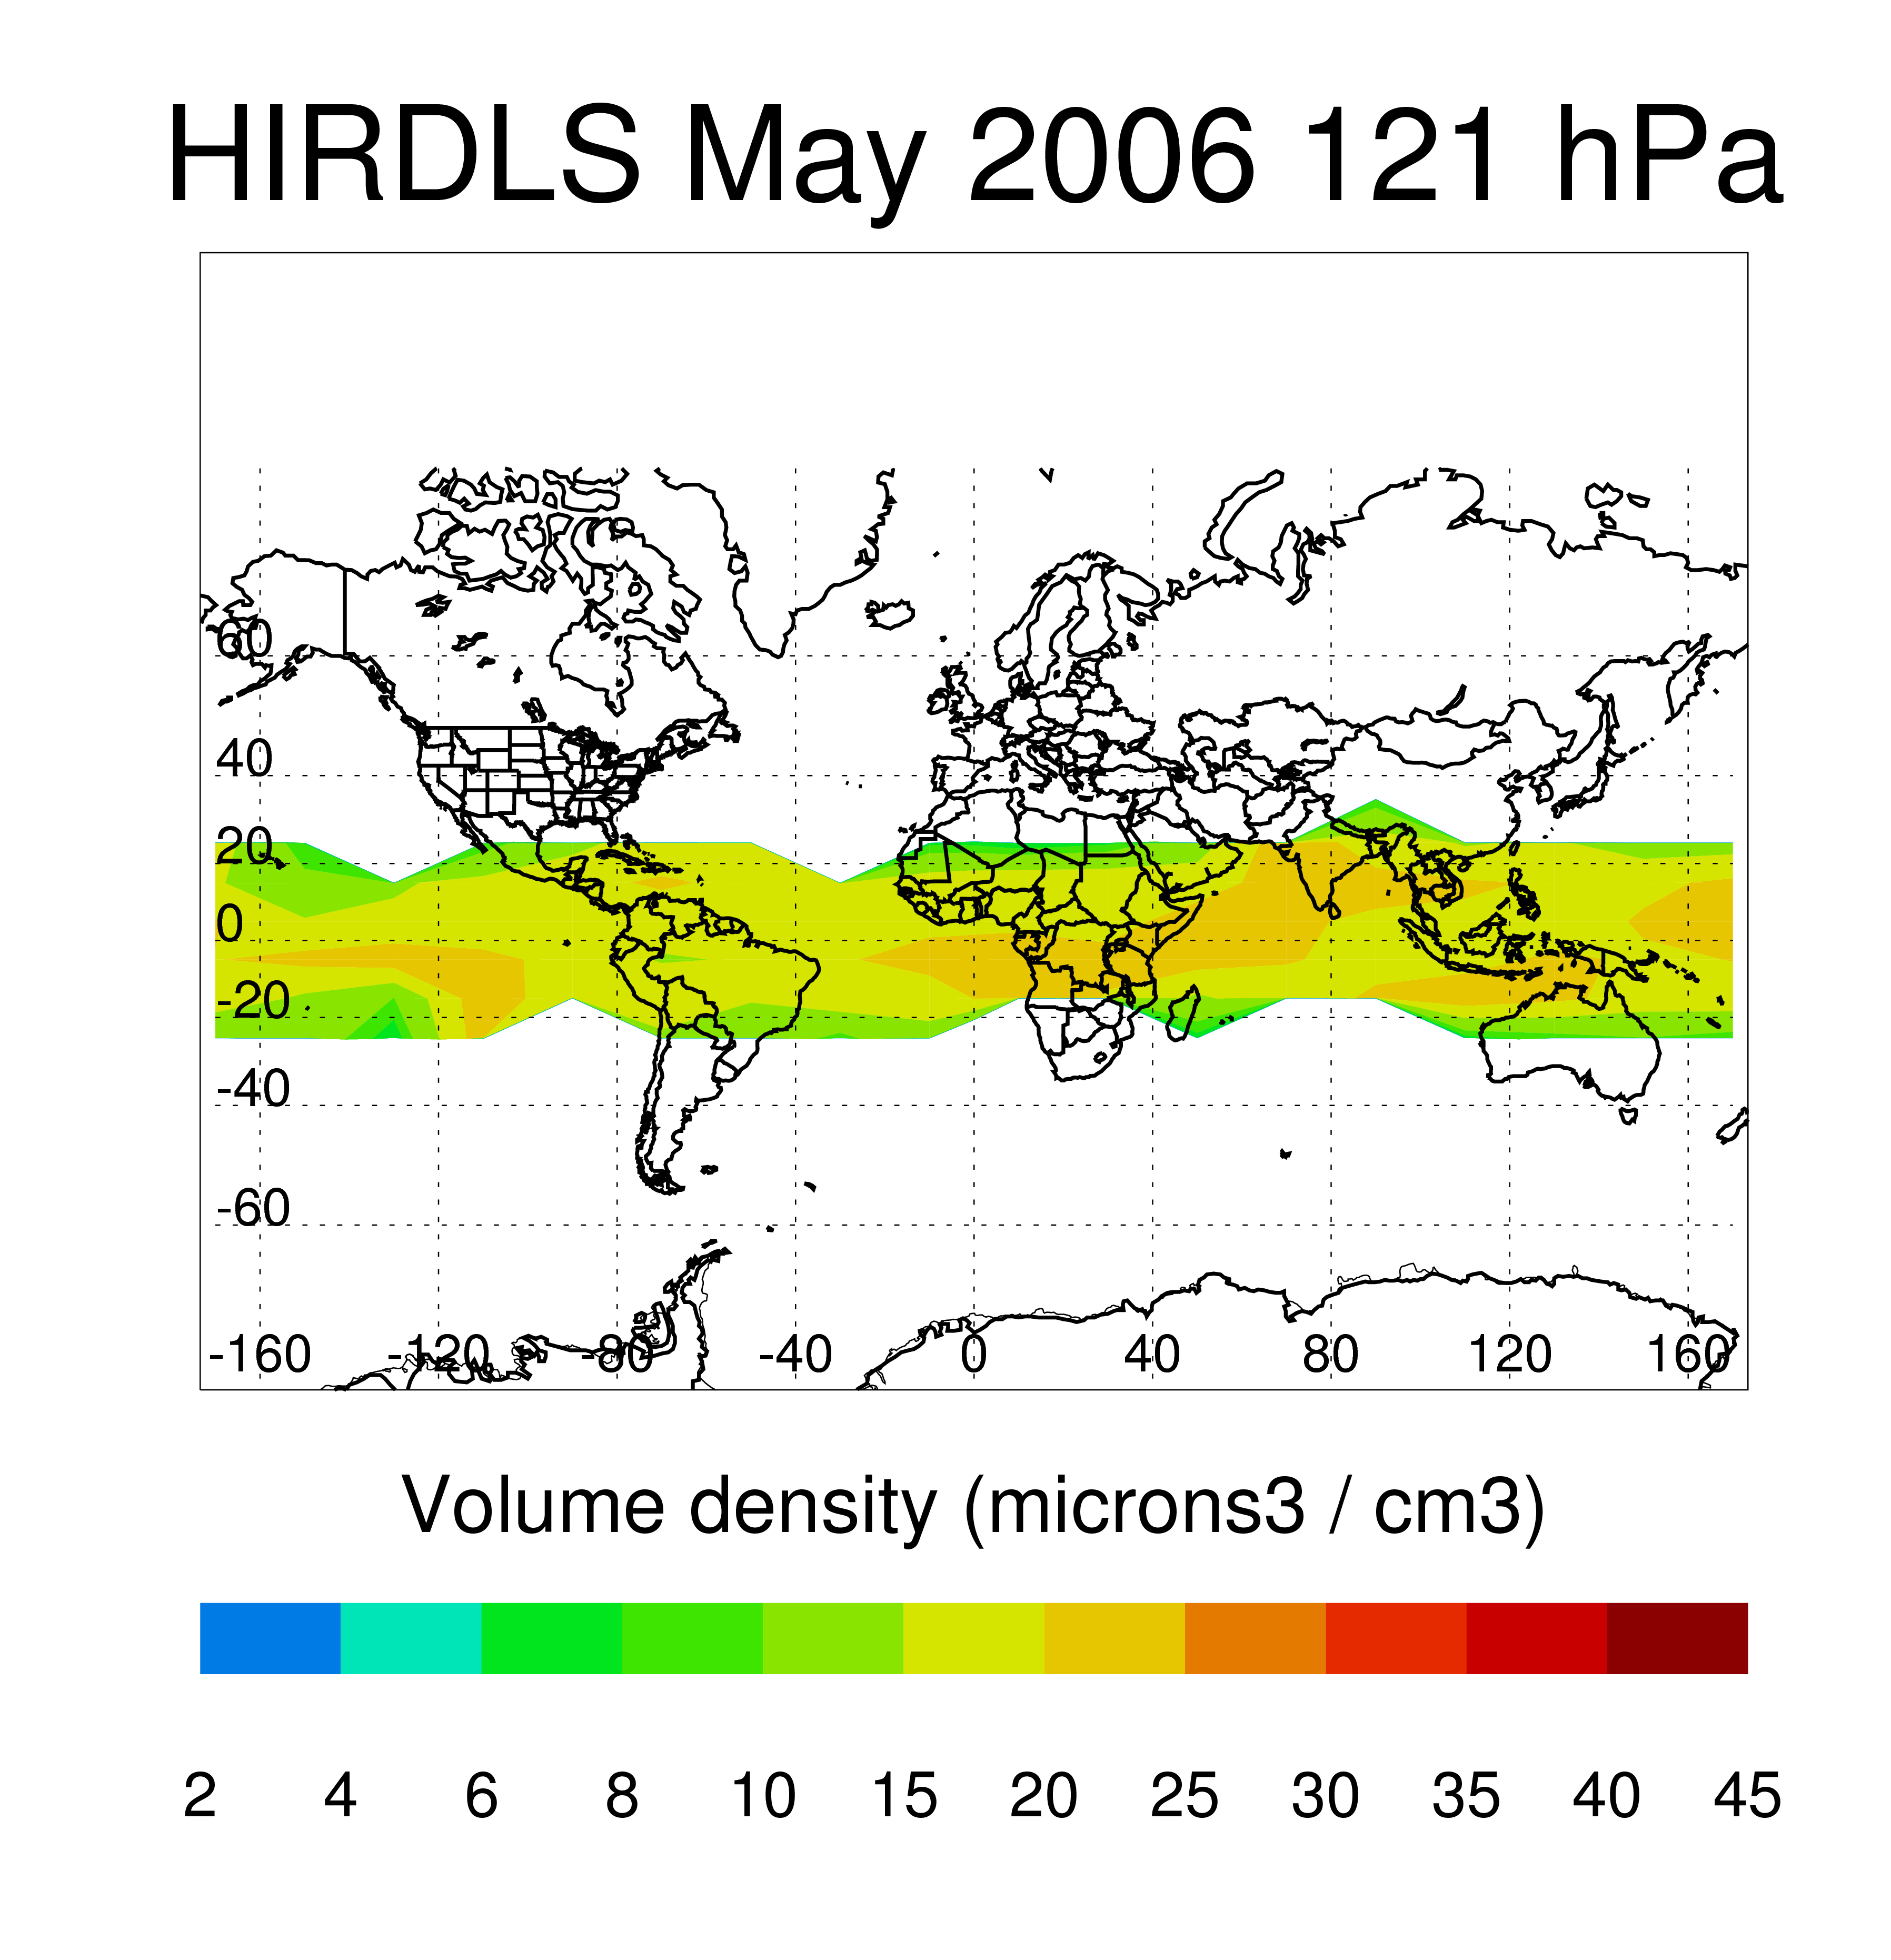
Figure 4. HIRDLS volume density (μm/cm³) at 121 hPa in May 2006.

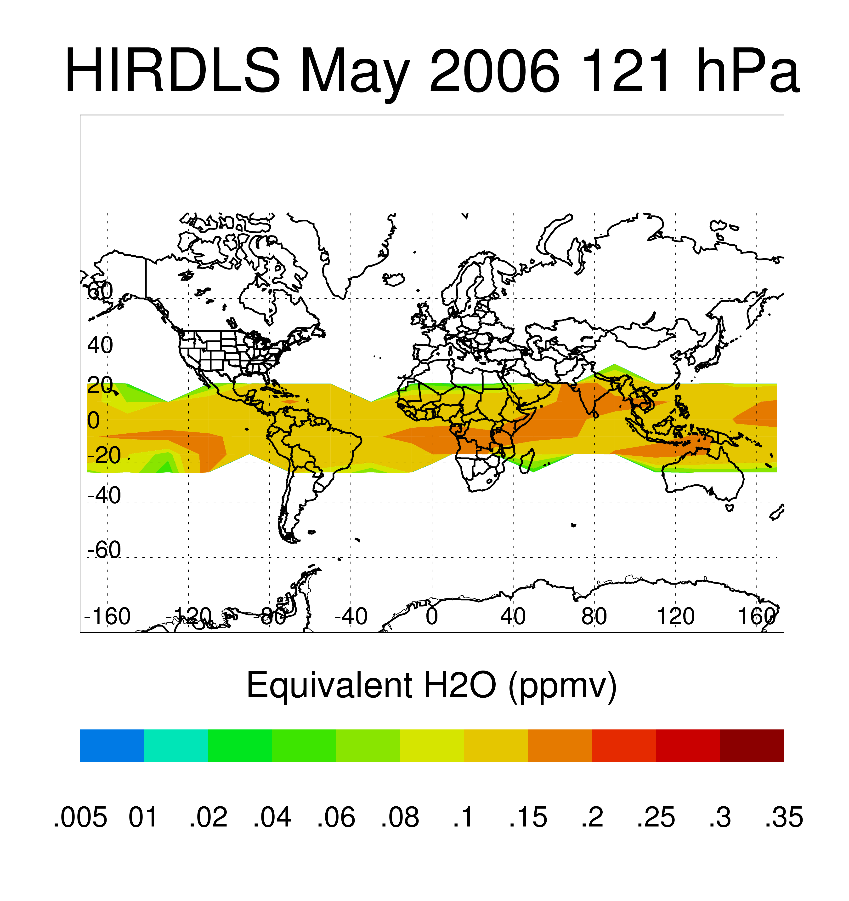
Figure 5. HIRDLS equivalent H₂O (ppmv) at 121 hPa in May 2006.

Data File Structure and Content

Contact: Vince Dean
Email: vdean@ucar.edu

Warning for IDL users: Due to internal changes within the HDF5 library used to create the IWC files, IDL must be upgraded to 7.1 in order to read this data.

The joint HIRDLS/MLS IWC data are stored in a single file using the HDF-EOS5 Grid format. The IWC file can be read via C/C++ or Fortran using either the HDF-EOS5 or HDF5 library. It is also possible to read the IWC data via netCDF calls using the netCDF4.1 and later libraries. Even though the data was written with HDF-EOS5, the netCDF4.1 and later libraries can read this file. It should be noted that versions prior to netCDF4.1 will not be able to read the IWC file. IDL also has the capability to read this file.
Users should obtain the pre-compiled HDF5 library for their operating system, if possible, otherwise source code is also available (see http://hdf.ncsa.uiuc.edu). These are prerequisite in order to compile the HDF-EOS5 library (see http://www.hdfeos.org/). Both libraries are needed to fully access the Aura HIRDLS data files. For additional help contact the GES DISC at help-disc@listserv.gsfc.nasa.gov or telephone 301-614-5224.

IWC Files
The IWC file contains monthly averaged, latitude/longitude gridded IWC from both MLS and HIRDLS. The data is written using the HDF-EOS5 Grid library. Each instrument’s values are stored in a separate Grid within the data file. The latitudes and longitudes are identical for the two instruments, but the pressure levels differ, with MLS being a subset of the pressures reported for HIRDLS.
Version information for the input HIRDLS and MLS data files can be found by viewing the INPUTPOINTER field in the .met file. This field contains the complete listing of files (including version number information) which were used to create this joint product file. It should be noted that for V1, the MLS data were prescreened by the MLS team (see the description above for more details).

References

Gille, J. et al. (2011), HIRDLS High Resolution Dynamics Limb Sounder
Earth Observing System (EOS) Data Description and Quality Version 7 (V7).

Livesey, N. et al. (2011), Version 3.3 Level 2 data quality and description document, JPL D-33509, January 18, 2011.

Massie, S., A. Gettelman, W. Randel, and D. Baumgardner, Distribution of tropical cirrus in relation to convection, J. Geophys. Res., 107(D21), 4591, doi:10.1029/2001JD001293, 2002.

Massie, S. T. et al., HIRDLS Observations of PSCs and Subvisible Cirrus, 2007: J. Geophys. Res., doi:10.1029/2007JD008788.

Wu, D.L, and Jiang, J.H., EOS MLS Algorithm Theoretical Basis for Cloud Measurements, JPL Technical Document, D-19299, Jet Propulsion Laboratory, 2004

Wu, D.L., J.H. Jiang, W.G. Read, R.T. Austin, C.P. Davis, A. Lambert, G.L. Stephens, D.G. Vane, and J.W. Waters, Validation of the Aura MLS Cloud Ice Water Content (IWC) Measurements, J. Geophys. Res. 113, doi:10.1029/2007JD008931, 2008.

